

<Draw It or Lose It>

CS 230 Project Software Design Template
Version 1.0

Table of Contents

CS 230 Project Software Design Template 1
Table of Contents 2
Document Revision History 2
Executive Summary 3
Requirements 3
Design Constraints 3
System Architecture View 3
Domain Model 3
Evaluation 4
Recommendations 5

Document Revision History

Version | Date | Author | Comments
1.0 | 10/18/2026 | Anthony Roberts | Reviewed the Recommendations section

Instructions
Fill in all bracketed information on page one (the cover page), in the Document Revision History table, and below each header. Under each header, remove the bracketed prompt and write your own paragraph response covering the indicated information.

Executive Summary

The Gaming Room needs to transition their current Android-only game, “Draw It or Lose It,” into a web-based application that can be accessed across multiple platforms. Right now, they lack the software design and environment setup to make this happen. The proposed solution is to develop a Java-based backend architecture that strictly manages the game’s state and memory. By using specific design patterns, we can ensure that multiple teams and players can interact with the game seamlessly. The most critical thing the client needs to know moving forward is that these software design decisions, like restricting the game to a single memory instance, must be finalized before we can determine the specific hardware and server requirements for the distributed web environment.

Requirements

The Gaming Room requires a cross-platform, web-based adaptation of their Android game “Draw It or Lose It.” The system must fulfill the following core software requirements:

- Hierarchical Structure: A single game must support one or more teams, and each team must support multiple assigned players.
- Unique Naming Validation: All game and team names must be strictly unique. The application must provide a way for users to verify if a chosen name is currently in use when creating a new team or game.
- Single Memory Instance: The backend architecture must ensure that only one instance of the game exists in memory at any given time. This requires implementing unique identifiers for every individual game, team, and player to manage state safely and prevent conflicts in a distributed environment.

Design Constraints

Moving to a web-based distributed environment introduces constraints around memory management, concurrency, and platform independence. Unlike a standalone Android app, a web app has to handle multiple users from different devices interacting with the server simultaneously. The main implication for development is that we have to strictly manage the application’s memory to avoid data conflicts or crashes. For example, we are constrained to keeping only one instance of the game in memory at any given time. This requires us to enforce unique identifiers and names for every game, team, and player to prevent users from overwriting each other’s data during concurrent play.

System Architecture View

Please note: There is nothing required here for these projects, but this section serves as a reminder that describing the system and subsystem architecture present in the application, including physical components or tiers, may be required for other projects. A logical topology of the communication and storage aspects is also necessary to understand the overall architecture and should be provided.

Domain Model

The UML diagram maps out the core data structure of the application, focusing on Game, Team, and Player objects.

The most prominent object-oriented programming (OOP) principle used here is Inheritance. To avoid duplicating code, there is a base class named Entity that contains the common attributes every object needs: a unique ID and a name. The Game, Team, and Player classes all inherit these traits from the Entity class. The diagram also relies heavily on Encapsulation, keeping these attributes private and only allowing access through specific getter and setter methods.

The classes are managed by the GameService class, which acts as the central hub. GameService utilizes the Singleton pattern to ensure only one instance of the game exists in memory, fulfilling a major software requirement. The service also uses the Iterator pattern to loop through existing records whenever a new game, team, or player is created. This efficiently fulfills the requirement that all names must be strictly verified as unique before they are added to the active game.

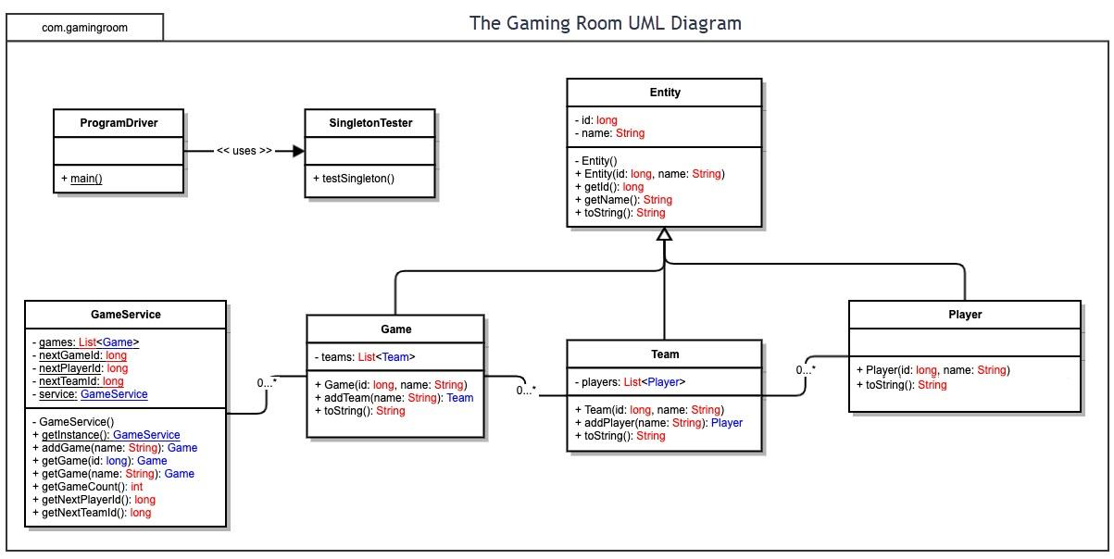

Evaluation

Using your experience to evaluate the characteristics, advantages, and weaknesses of each operating platform (Linux, Mac, and Windows) as well as mobile devices, consider the requirements outlined below and articulate your findings for each. As you complete the table, keep in mind your client’s requirements and look at the situation holistically, as it all has to work together.

In each cell, remove the bracketed prompt and write your own paragraph response covering the indicated information.

Development Requirements | Mac | Linux | Windows | Mobile Devices
Server Side | Hosting: Lacks enterprise server clustering software, unsuitable for scaling to thousands of players.  Advantage: Good for local development if the team already uses Apple hardware.  Weakness: Can’t scale horizontally in non-Apple cloud environments.  Costs: The OS is free, but Apple hardware is expensive to use as dedicated servers. | Hosting: The industry standard for web hosting. Easily scales to thousands of players using cloud containers  Advantages: Lightweight, highly secure, and massive enterprise community support.  Weakness: Steep learning curve CLI expertise to manage.  Costs: Open source distributions (Ubuntu, Debian) are free. | Hosting: Fully capable of hosting scalable web apps via IIS and the Azure cloud.  Advantages: Familiar GUI and seamless Microsoft enterprise integration.  Weakness: Higher resource overhead and more background services compared to Linux.  Costs: High, requires per-core commercial licensing Windows Server. | Hosting: Designed strictly as client devices. They can’t function as web servers to host the game.  Advantage: Energy-efficient architectures, but irrelevant for server hosting.  Weakness: Strict network sandboxing, thermal throttling, and no enterprise server software.  Costs: No server OS licensing, but requires developer account fees for app store deployment.
Client Side | Considerations: Delivered via browsers like Safari or Chrome. Requires responsive HTML5/CSS3  Cost/Time/Expertise: Low cost and time. Requires standard web development expertise and QA testing for Safari’s specific WebKit engine. | Considerations: Delivered via open-source browsers like Firefox or Chromium.  Cost/Time/Expertise: Minimal cost. Web standards ensure the game runs cleanly without native Linux binaries. Requires standard frontend expertise. | Considerations: Delivered via Edge or Chrome. Must adapt to various desktop resolutions and input types (mouse/touch laptops).  Cost/Time/Expertise: Fast time-to-market. Requires standard web developer expertise and testing for multi-monitor scaling. | Considerations: Replaces the native Android app with a responsive HTML web app in mobile browsers. Must scale UI for small screens and support touch events.  Cost/Time/Expertise: Saves significant time and money over building separate native iOS and Android apps. Requires frontend expertise in mobile layout optimization.
Development Tools | Languages and Tools: Java, HTML/CSS/JS, IDEs include Eclipse and VS code.  Licensing: Development tools are free/open-source.  Team Impact: A single full-stack web team can build both ends without needing platform specialists. | Languages and Tools: Java, HTML/CSS/JS. IDEs include Eclipse, IntelliJ, and VS Code.  Licensing: Compilers and community IDEs are free/open-source.  Team Impact: Unifies the team workflow since local development matches the production server environment perfectly. | Languages and Tools: Java, HTML/CSS/JS. IDEs include Eclipse and VS Code. WSL 2 allows Linux testing.  Licensing: Free for open-source tools; Visual Studio enterprise editions cost extra.  Team Impact: A single web team can handle all cross-platform development locally. | Language and Tools: Desktop IDEs combined with free mobile emulators (Android Studio, Xcode Simulator)  Licensing: Emulators and browser developer tools are free  Team Impact: Moving to a responsive web app eliminated the need for separate, expensive iOS and Android native development teams.

Recommendations

Analyze the characteristics of and techniques specific to various systems architectures and make a recommendation to The Gaming Room. Specifically, address the following:

- Operating Platform:
I recommend Linux as the primary operating platform for hosting the backend of the game. Linux is the industry standard for web hosting because it is open-source, highly secure, and extremely efficient with system resources. For the client side, since the goal is cross-platform compatibility, building a responsive web-based application is the best approach. This allows the game to be played on any device like Windows, Mac, Linux, or mobile, simply by using a standard web browser, without needing to develop native apps for each system.

- Operating Systems Architectures:
Linux utilizes a monolithic kernel architecture. This means the core operating system services such as CPU scheduling, memory management, file systems, and network protocols, all run in the same central memory space. This architecture allows the server to process concurrent requests from multiple players very quickly, as there is minimal overhead when the software needs to communicate with the server’s hardware.

- Storage Management:
For storage management, Linux uses a Virtual File System (VFS), which allows the server to interact with different physical storage devices seamlessly. At the application level, I recommend using a robust database management system, such as a relational database or a NoSQL database. This system will securely store persistent data that shouldn’t just exist in active memory, such as user accounts, historical team statistics, and the library of stock drawings.

- Memory Management:
Linux manages memory using virtual memory and paging. It allocates specific, isolated blocks of memory (pages) to running applications. If the physical RAM gets full, Linux seamlessly moves inactive data to a space on the hard drive (swap space) to keep the system from crashing. For “Draw It or Lose It,” this ensures that the Java application’s strict requirement of maintaining only one instance of the GameService in memory is protected.

- Distributed Systems and Networks:
To allow “Draw It or Lose It” to communicate across platforms, the system will use a Client-Server architecture over the internet (TCP/IP networks). The central Linux server will host the game logic and state, and the players' devices act as clients. For real time gameplay, the application should use WebSockets for a persistent, two-way connection, rather than standard HTTP requests. To mitigate network issues like connectivity drops, the client-side code should include logic to automatically attempt reconnection, while the server should be programmed to pause a user’s session temporarily rather than booting them immediately if a brief outage occurs.

- Security:
Security must be implemented at both the network and application levels.
- Data in Transit: All communication between the players’ devices and the server must be encrypted using HTTPS (SSL/TLS protocols) to prevent interception of user data.
- Platform Security: At the server level, Linux offers robust built-in security, including strict user permissions and powerful firewall configuration tools to block unauthorized network traffic.
- Application Security: The game must sanitize all user inputs (like team names or guesses) to prevent injection attacks, and user authentication systems must store passwords using strong cryptographic hashing algorithms, never plain text.

